Caption Sheet
Image | Credit
Marina Abramović Great Wall Series
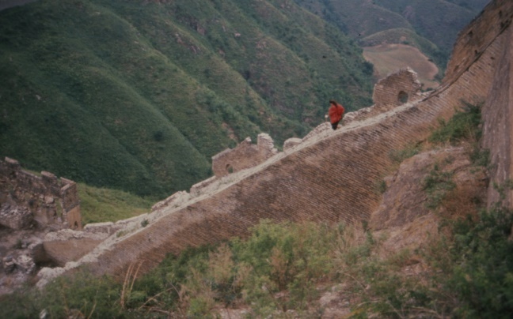 | Marina Abramović  Great Wall of China  Landscapes and Portraits  1988  Courtesy of the Artist
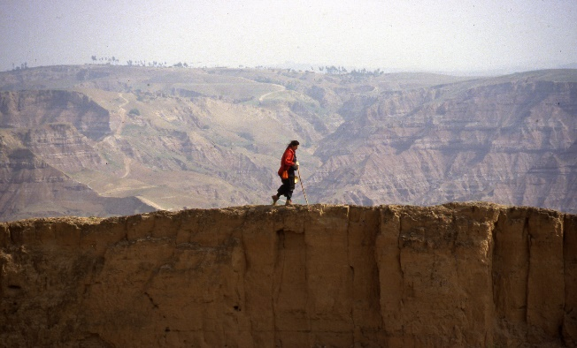 | Marina Abramović  Great Wall of China  Landscapes and Portraits  1988  Courtesy of the Artist
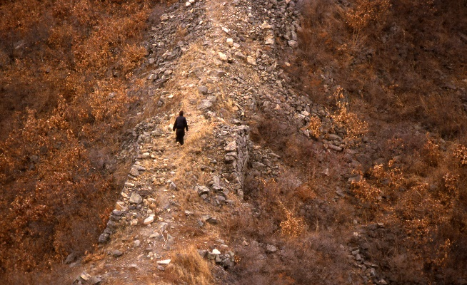 | Marina Abramović  Great Wall of China  Landscapes and Portraits  1988  Courtesy of the Artist
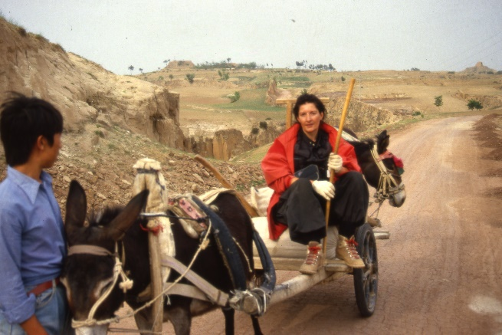 | Marina Abramović  Great Wall of China  Marina and People  1988  Courtesy of the Artist
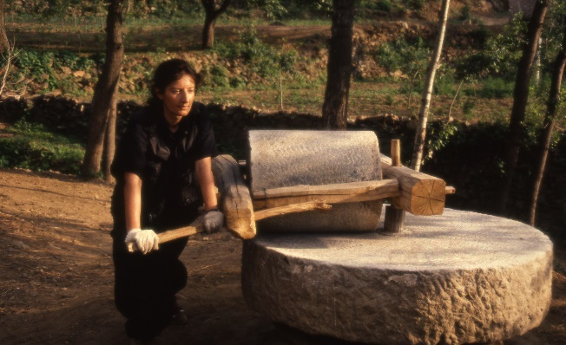 | Marina Abramović  Great Wall of China  Portraits of Marina  1988  Courtesy of the Artist
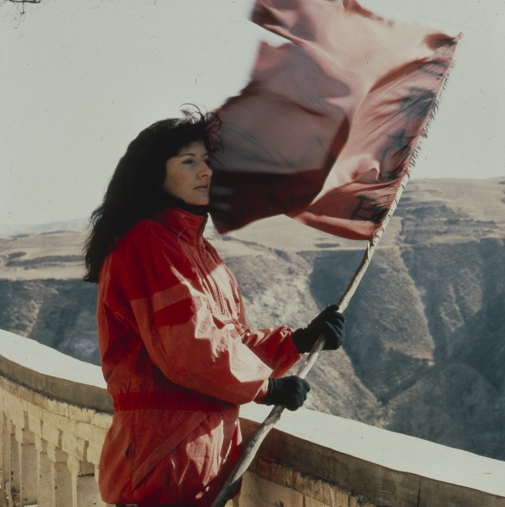 | Marina Abramović  Great Wall Walk, China  Marina on the Wall  1988  Courtesy of the Artist
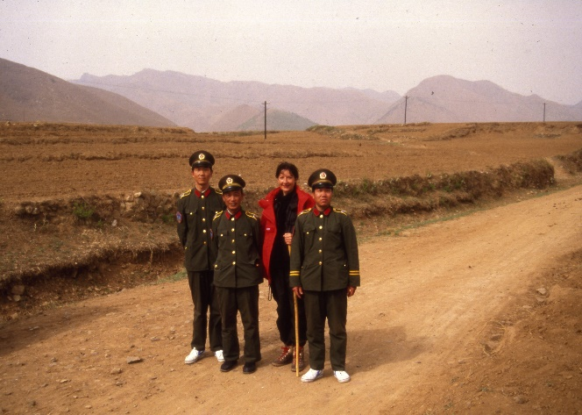 | Marina Abramović  Great Wall Walk, China  People and Buildings  1988  Courtesy of the Artist
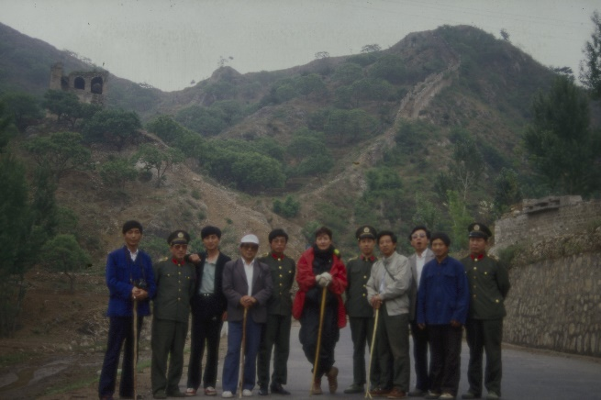 | Marina Abramović  The Great Wall Walk  China Group Portraits  1988  Courtesy of the Artist
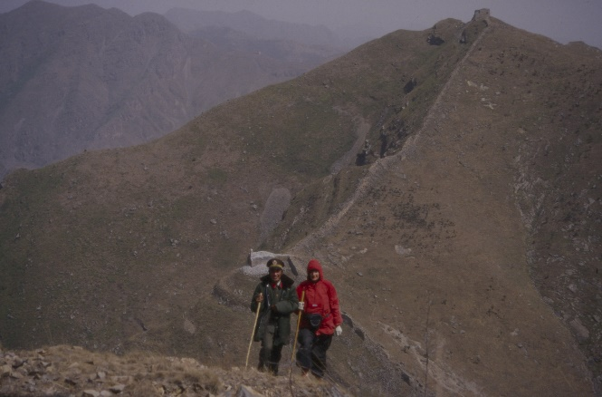 | Marina Abramović  The Great Wall Walk  China Guides  1988  Courtesy of the Artist
Marina Abramović Works Images
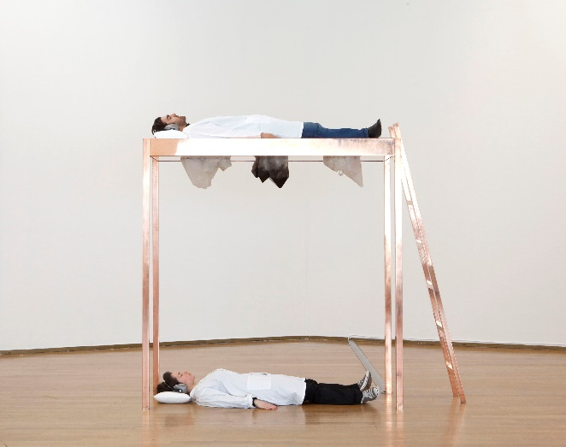 | Marina Abramović,  Copper Bed for Human Use, 2012, copper, quartz stones, 210 x 200 x 70 cm, unique,  Photography by Fabrizio Vatieri,  Courtesy Sean Kelly Gallery
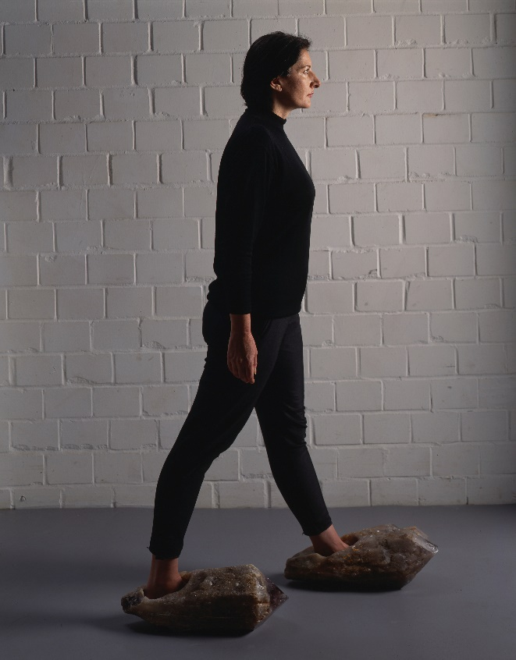 | Marina Abramović,  Shoes for Departure, 1991/2017,  quartz crystal, amethyst crystal,  dimensions vary,  approx. 8 5/8 x 21 1/4 x 10 inches/ each, unique, Courtesy Sean Kelly Gallery
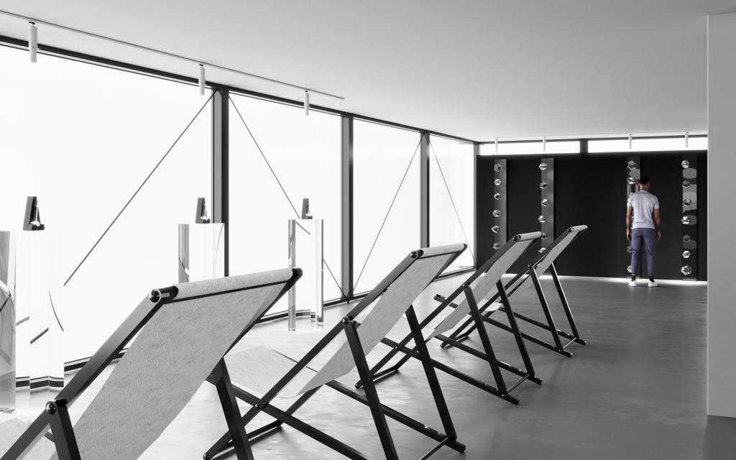 | Marina Abramović  Transitory Object Grounder Rendering  2024  Courtesy of MAM Shanghai
Marina Abramović Portraits
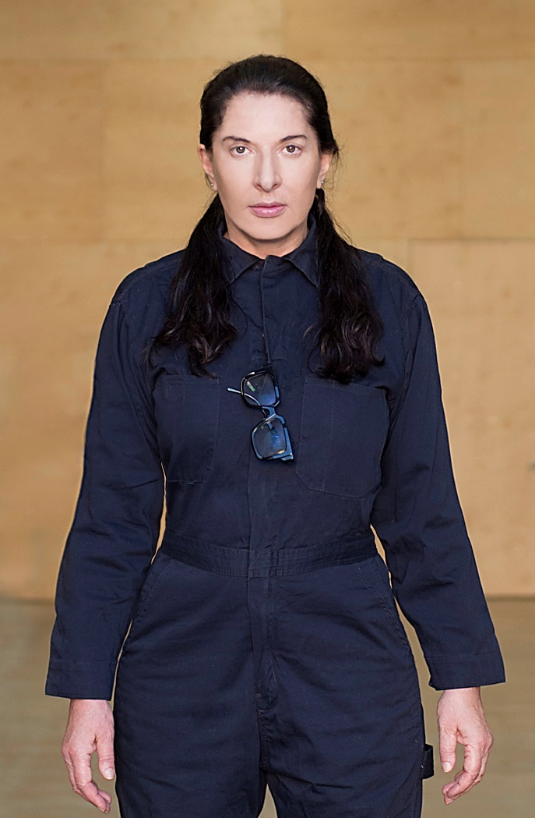 | Marina Abramovic, 2016  Photograph by Reto Guntli
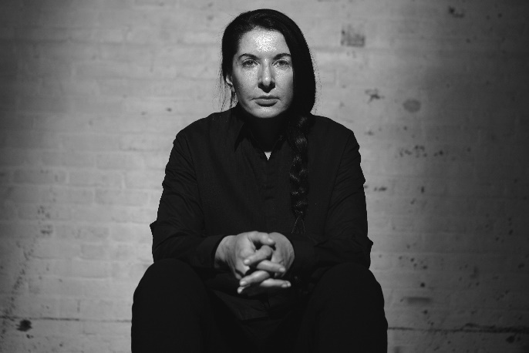 | Marina Abramovic, 2018  Photography by Dusan Reljin
Shai Baitel and Marina Abramović
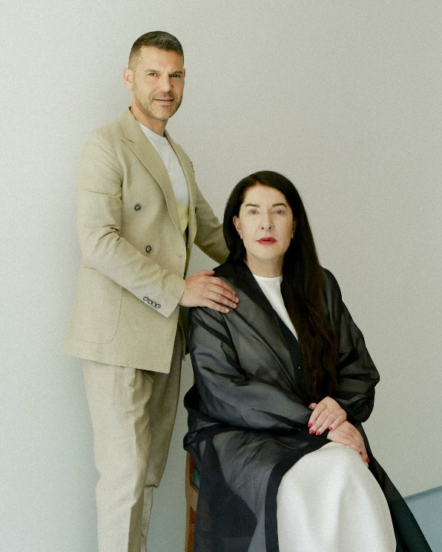 | Shai Baitel and Marina Abramović, 2024  Photography by Clara Melchiorre
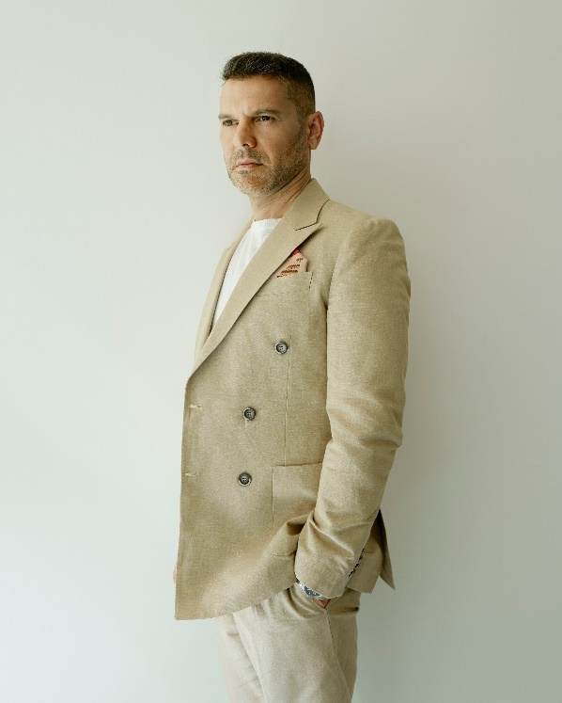 | Shai Baitel, 2024  Photography by Clara Melchiorre

